**Simulating Predator-Prey Dynamics using Lotka-Volterra Equations in Python**

**Introduction**

This document outlines a Python implementation for simulating predator-prey dynamics using the Lotka-Volterra equations. The code employs the NumPy library for numerical computations and Matplotlib for visualizations.

**Lotka-Volterra Equations**

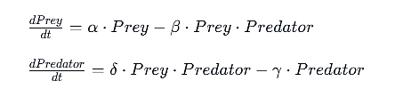The implemented function, lotka_volterra models the interaction between prey and predator populations. The equations are expressed as follows:

* α: Prey birth rate
* β: Predation rate
* δ: Predator death rate
* γ: Predator reproduction rate

**Implementation**

The Python code begins by defining the Lotka-Volterra function, which takes initial population conditions, and model parameters as inputs. The function then iteratively computes the population dynamics using the Lotka-Volterra equations. The simulation ensures that populations remain non-negative. The simulation is based on the following parameters:

* Prey birth rate
* Predation rate
* Predator death rate
* Predator reproduction rate

**Visualization:**

The module Matplotlib is used to create a plot showcasing the dynamics of prey and predator populations over time. The x-axis represents time, and the y-axis represents population size. Different colors distinguish prey and predator populations. The resulting graph provides a visual representation of how the populations evolve based on the specified model parameters.

**Conclusion:**

This Python script offers a basic yet insightful simulation of predator-prey dynamics using the Lotka-Volterra equations. You can experiment with different parameter values and initial conditions to observe how changes impact the dynamics of the ecosystem.